Automation Proposal - Recipe Manager Web App
TC ID | Test Case Name | Description | Test Data | Why Automate
TC_A01 | Create Recipe | Verify user can create a full recipe with required fields, image URL, ingredients & steps. | Title: Veg-Biryani (2 peoples) Ingredients: Rice 2 Bowl, Oil 100 ml, Water 500 ml, Salt 0.2 tsp, Jeera 1 tsp, Elaichi 2, GingerGarlic 0.5 tsp, Peanuts 50 gm,  Cashew 30 gm, Curry Leaves 8– 9, Curd 2 tsp, Vegetables list etc.  Steps: Full procedure lines  Tags: Main Course, Vegetarian  Image URL: Valid URL | High business value, core flow, required in every release, stable & deterministic.
TC_A02 | Edit Recipe | Ensure editing updates ingredient quantity & steps correctly and persists after save. | Update Oil from 100 ml → 120 ml  Add one additional cooking step Verify UI shows updated data & backend/API consistency | Common regression area, repeatable, low flakiness.
TC_A03 | Input  Validation | Confirm UI rejects invalid image URLs & invalid numeric values. | Invalid URL: "not_a_url"  Invalid Qty: Water = -100 or "five hundred"  Ensure proper error messages | Negative tests are deterministic and reliable for automation.
TC_A04 | Search & Filter | Validate search & filter return correct recipe. | Search: “biryani”  Filter: Vegetarian, Ingredient =  Rice, Servings = 2 peoples | Core functionality, logic-heavy, prone to regressions, predictable output.
TC_A05 | Delete Recipe | Verify deletion works and recipe is removed from list + search results. | Delete Veg-Biryani recipe  Confirm recipe disappears from  UI  If soft-delete: verify it appears in  Trash & can be restored | Safety-critical flow, strong candidate for regression automation.

Justification
- These flows are deterministic, fast, and executed frequently as regression checks. They verify core CRUD and content rendering which are high-risk for business.
- Automating create/edit/delete ensures test data lifecycle: create recipe, verify, edit, verify, delete (teardown).
- Image URL tests validate front-end rendering and fallback logic programmatically.

Pseudo-automation framework (Playwright recommended)
- Language: Playwright (Node.js). I prefer Playwright for faster test runs and built-in waiting.
- Test runner: Playwright Test (or Jest + Playwright).
- Assertions/reporting: Playwright Test + Allure or built-in reporter.

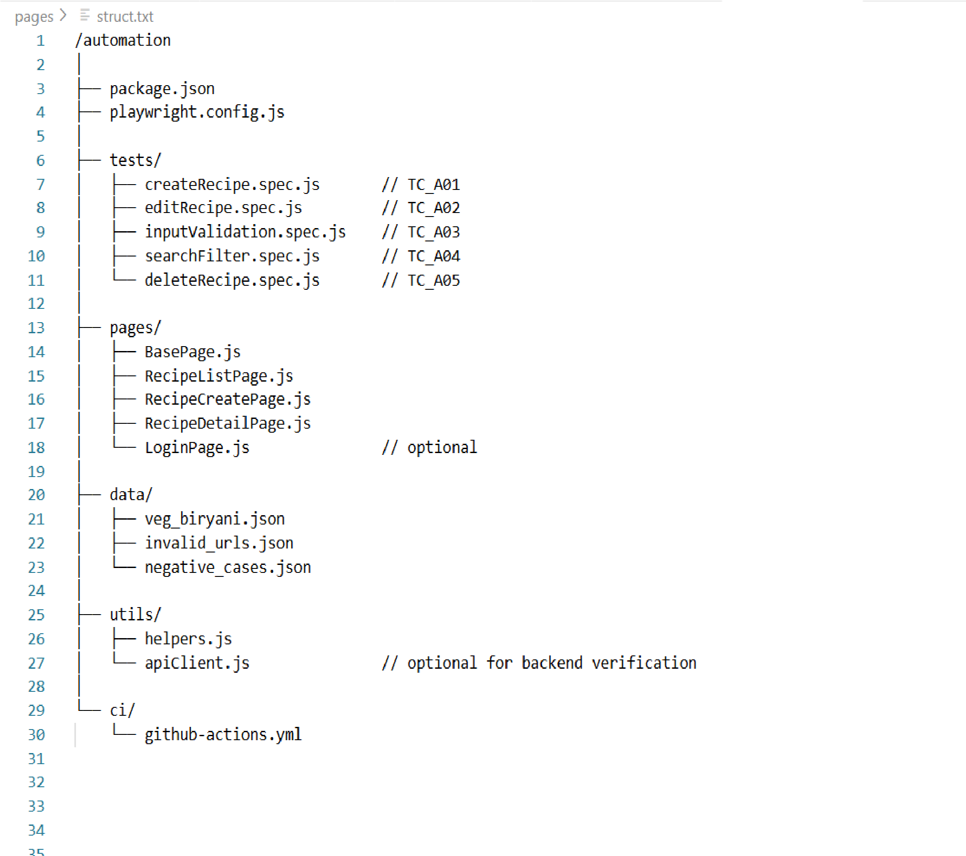
Folder Structure
Sample Page Object (Playwright + JavaScript)
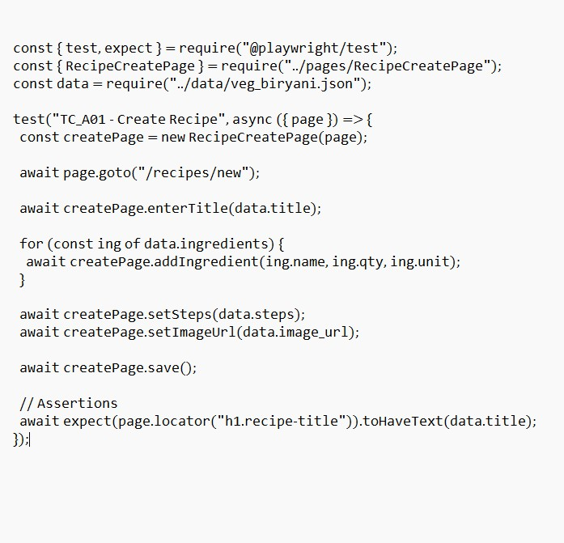

Sample Test File (Playwright + JavaScript)

